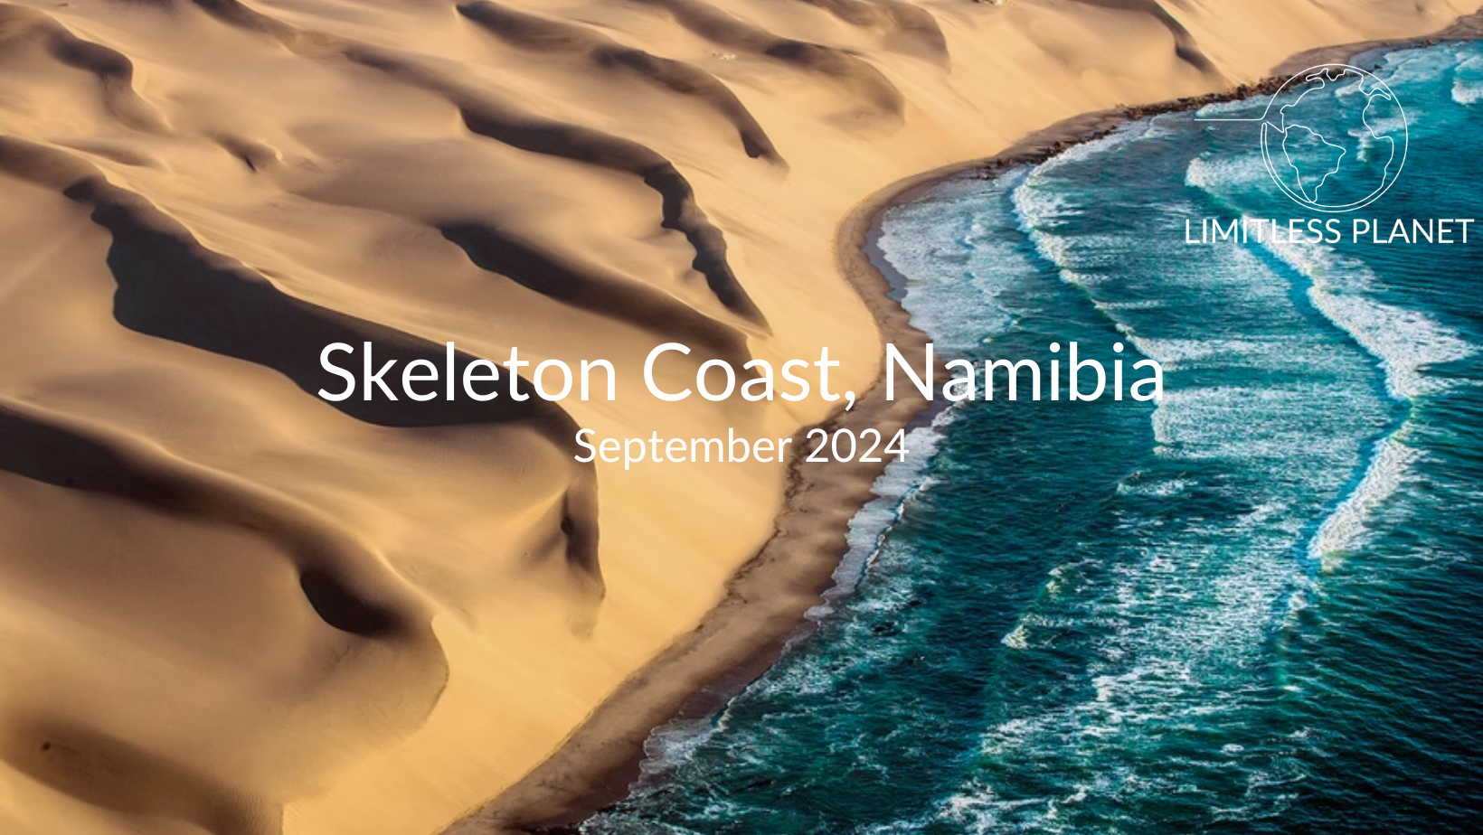
This post trip extension is offered in conjunction with the main trip to Namibia. If you would like to book this trip extension please reach out to your Account Manager, Christian Lewis. Please note that this is a trip to one of the most remote locations on the planet. In order to participate you must not have any active medical conditions.
Day 1. September 21st, 2024: Overnight in Windhoek
Meals: Brekfast
Today after saying farewell to the main group we will overnight in Windhoek to prep for a full travel day to Namibia’s storied Skeleton Coast.
Spend your day at leisure relaxing at our hotel or exploring Windhoek.
Overnight: The Weinberg, Windhoek
Day 2. September 22nd, 2024: Windhoek to the Skeleton Coast
Meals: Breakfast, lunch, and dinner
This morning after breakfast, we will meet our transfer outside our accommodations and set off for the Skeleton Coast via light aircraft.
Once we are settled in our accommodations we will set off for our afternoon tour of Möwe Bay to explore the dangerous beauty of the Skeleton Coast. Either on your way to the lodge from Möwe Bay or returning from the lodge, you will see what is left of the victims of this treacherous coastline: Decaying ships, the remains of a Ventura Bomber and the abandoned Westies Diamond Mine bear witness to the unforgiving nature of this arid landscape. You will also visit the seal colony.
This evening before having dinner as a group we will enjoy a stunning sundown drive to the Roaring Dunes where the desert’s voice can be heard.
Overnight: Shipwreck Lodge, Namibia
Day 3. September 23rd, 2024: Skeleton Coast
Meals: Breakfast, lunch, and dinner
After enjoying breakfast together we will set off for our first adventure of the day!
Spend your morning exploring the Hoarusib River. Visit the Clay Castles, a striking geological formation. You might even spot the elusive desert-adapted elephants, brown hyenas and lions.
This afternoon is for the thrill seekers! We will spend our afternoon sandboarding down the giant sand dunes Namibia is so famous for!
After an high adrenalin afternoon we will join back together for a relaxing dinner and talk about the days adventures.
Overnight: Shipwreck Lodge, Namibia
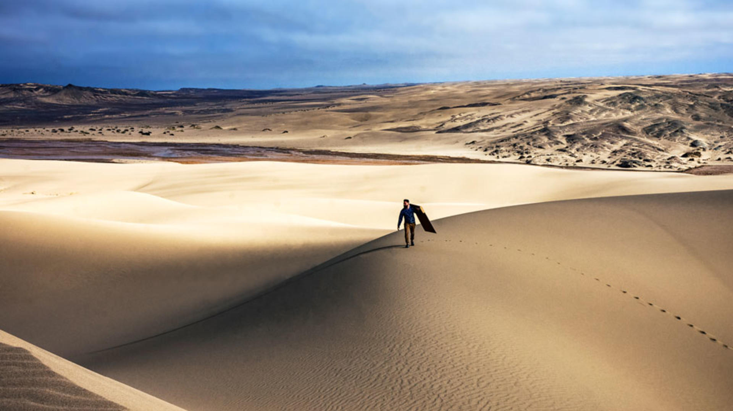
Day 4. September 24th, 2024: Skeleton Coast
Meals: Breakfast, lunch, and dinner
After breakfast, we will set off for a special scenic tour of the Roaring Dues on quad bikes! This tour is specially designed by the Ministry of Environment for us to cover as much territory as possible while still minimizing any effects on the environment.
This afternoon after freshening up from our quad bike tour we will set off for a very special lunch to celebrate our last day on the Skeleton Coast. Weather permitting, we will enjoy a scrumptious lunch on the vast empty beach. Feel the crisp sea-breeze tousle your hair and ponder the meaning of life as the ocean washes onto the pristine sand in its unending ebb and flow.
Tonight, we will enjoy our final evening at leisure before joining together for one last dinner!
Overnight: Shipwreck Lodge, Namibia
Day 5. September 25th, 2024: Depart Skeleton Coast for US.
Meals: Breakfast
This morning we will depart for the Skeleton Coast and make our way back to Windhoek via light aircraft. From here we will board our connecting flights back to Cape Town, South Africa and depart for the United States.

Thank you for traveling with Limitless Planet!
Total Trip Cost: $8,977
*Price based on double occupancy.
Please note this trip can only operate if six people are confirmed. If this minimum is not met, you will be fully refunded.
Included:
1-night The Weinberg Hotel in a courtyard upper level room on a bed and breakfast basis
3-nights Shipwreck Lodge on a full board basis including all meals and beverages, WiFi, guest laundry, daily activities and airstrip transfers
Road transfer from Windhoek Airport to the Weinberg Hotel
Road transfer from the Weinberg Hotel to Eros Airport
Light aircraft seat-in-plane flight: Eros/Skeleton Coast/Windhoek - please note strict 44lbs per person luggage restriction in SOFT bags
Conservation levies and park fees
Assistance at either Cape Town airport OR Johannesburg airport (if required)
Value Added Tax (VAT)
Excluded:
Shipwreck Lodge excludes: Premium brand drinks, gratuities and fully comprehensive travel insurance
Any flights not specified
Any meals not specified
Any items of a personal nature such as gift shop purchases
Any tips or gratuities
Any travel insurance: fully comprehensive travel insurance required
Anything not specified above
Lodging Highlights
Below is are some highlights of our incredible accommodations on this trip!
Windhoek, Namibia: The Weinberg Windhoek
Windhoek is Namibia’s capital, home to an international airport and a plethora of restaurants, shops, entertainment venues, and lovely hotels such as The Weinberg. Enjoy luxurious accommodations as well as a beautiful rooftop bar and restaurant. Perfect for a sundowner cocktail and tappas dinner!

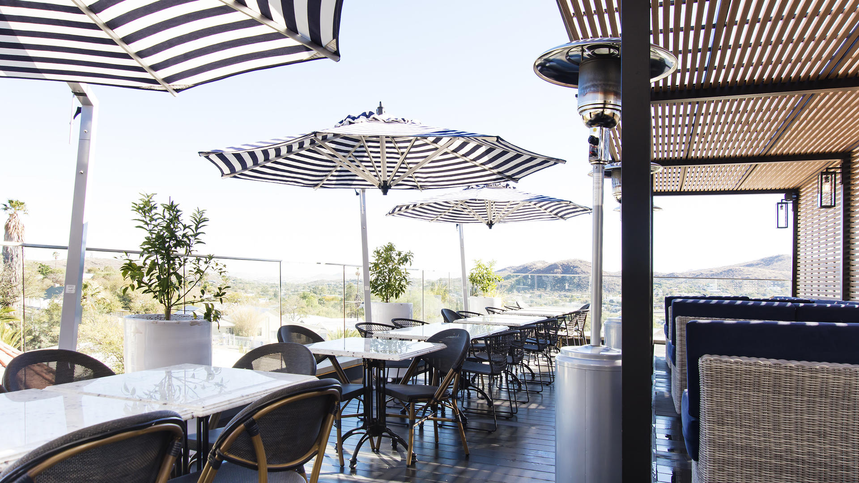

Skeleton Coast, Namibia: Shipwreck Lodge
Known as one of the most remote locations on the planet, the Skeleton Coast is known for its brutal, yet beautiful desert landscapes. The Shipwreck Lodge offers you luxurious private villa accommodations with incredible views or the surrounding desert. Enjoy delicious meals, inventive cocktails, and luxurious finishes.

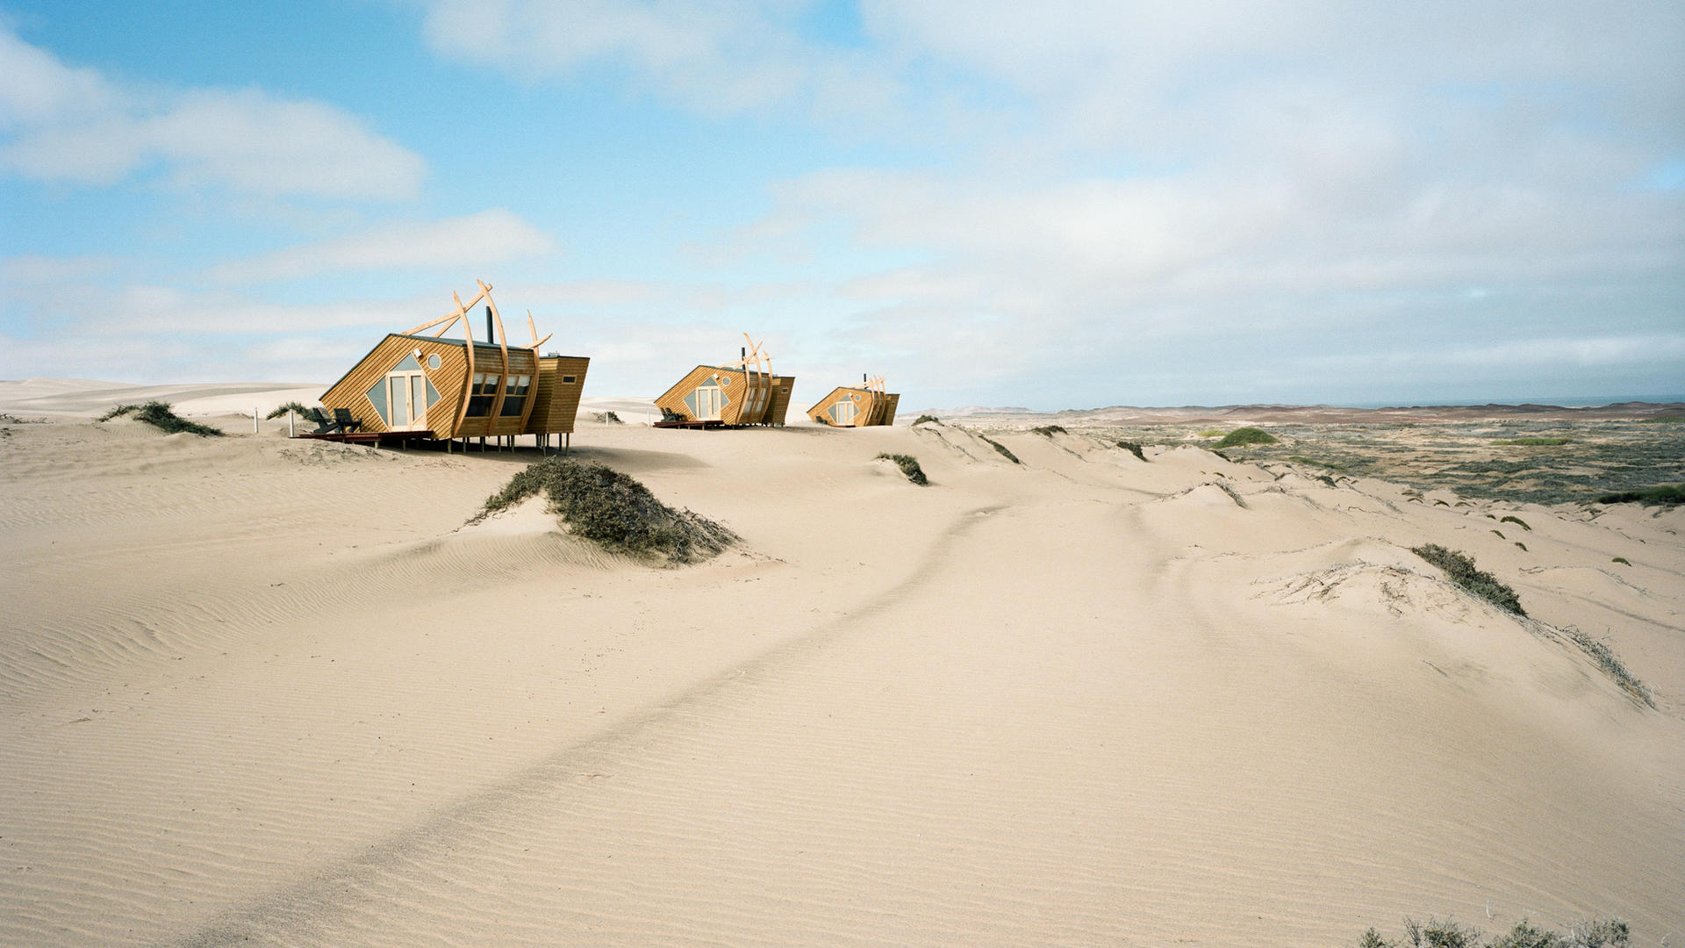
GENERAL INFORMATION:
Flights
If you would like Limitless Planet to make your flight arrangements, please reach out to your Account Manager. If you would like to use points or miles to book your flight, you will be in charge of booking your own flight.

Passport
Each traveler will be required to have a passport valid for at least six months after your travel departure date. Limitless Planet is happy to assist you with your passport application or renewing an expired passport. Additional fees may apply. Please send a copy of your valid passport with your deposit payment.

Visa
A free tourist visa will be issued to you upon your arrival in South Africa if you are over the age of 18. If you are a minor traveling with your parent or guardian, then you are exempt from this Visa issuing.

Travel Insurance
Travel insurance is not included in the quote of this itinerary. For your convenience Limitless Planet offers travel protection plans through Travelex Insurance Services. We are happy to send you a quote. A Limitless Planet Travel staff member will be onsite to assist in case of any emergency.

Concierge Service
Limitless Planet is happy to provide on-site VIP Concierge Service for the duration of your trip. Our on-site guides will ensure your restaurant reservations are made and your flights are on time. Our guides are experienced in managing the most intricate on-site details of today’s complicated programs. Be rest assured, you will have on-site assistance for any issue that occurs during your travels.

Health & Wellness
Your health and wellness are very important to us. We are happy to accommodate any dietary restriction and special requests. All participants of Limitless Planet’s tours must be physically fit enough to participate on the tour. Limitless Planet reserves the right to deny participation on any of our tours, according to the tour itinerary.

All guests are REQUIRED to have a COVID vaccination to travel with Limitless Planet.
IMPORTANT:
For every booking entrusted to us, we require the following information:
- Full passengers ́ name, date of birth, nationality & passport number
- International arrival/departure flight (if not arranging through Limitless Planet)
- Active medical problems
- Bed preference (subject to availability)

LIMITS ON LIMITLESS PLANET’S RESPONSIBILITY:
Limitless Planet acts as Tour Operator. It purchases transportation, hotel accommodations, restaurants and other services from various independent suppliers that are not subject to its control. Limitless Planet cannot, therefore, be liable for death, personal injury or any other loss that may occur due to any act or omission of any such a supplier or by reason of any other event over which it has no control. Domestic flights are, occasionally, subject to overbooking, cancellation, and schedule changes. If this occurs, Limitless Planet will do all in their power to assist clients in boarding flights or finding alternate arrangements. It must be stressed that this is done as a courtesy to clients and Limitless Planet cannot be held responsible for denied boarding, nor for the additional costs thus incurred; nor for payments not recovered for missed land arrangements due to airline delays.

Optional Activities that may be Dangerous
Depending on the itinerary you have selected, optional activities will be available at some of the places they will visit. Some of these activities carry with them the inherent risk of serious personal injury. These activities include, but are not limited to horseback tours, canoe trips, hiking, river rafting, etc. You should be aware that your personal safety cannot be guaranteed, and Limitless Planet assumes no responsibility for your safety.

Acts of God and the Like
Limitless Planet is not responsible for acts of God, fire, acts of local government or other authorities, wars, civil disturbances, riots, terrorist acts, strikes, thefts, pilferage, epidemics, quarantines, earthquakes, adverse weather conditions, dangers incident to sea, land, and air travel and other similar acts or incidents beyond its ability to control or its suppliers.

