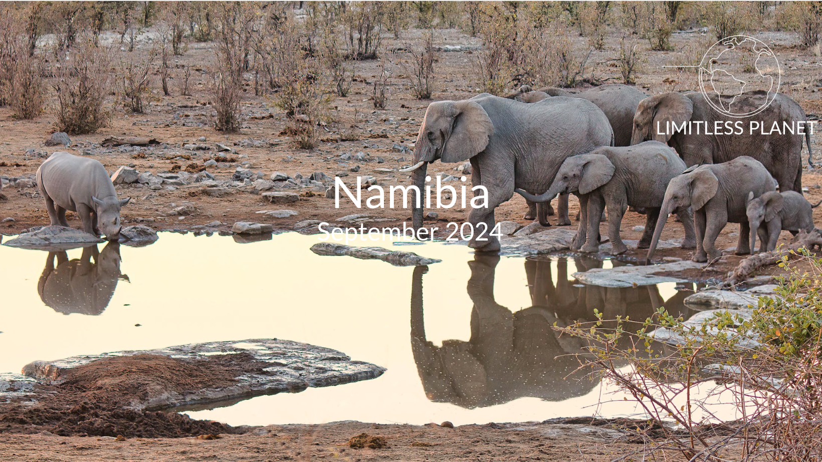
Day 0. September 13th, 2024: Arrival flight
Flight out of Chicago/STL.
Day 1. September 14th, 2024: Arrival in Cape Town
On arrival in Cape Town, you will be met and transferred to your hotel in the waterfront. The rest of the evening is at your leisure.
We will enjoy a meal together before calling it an early night in preparation for our flight to Namibia the next day.
Overnight: Derwent House Boutique Hotel, Cape Town
Day 2. September 15th, 2024: Cape Town to Namibia
Meals: Dinner
Late this morning you will be transferred to the airport in time for your flight to Walvis Bay in Namibia. On arrival you will be met and transferred to your guesthouse perched on the edge of the desert. Enjoy dinner in town at a local restaurant.
The Tug Restaurant is popular amongst both tourists and locals in Namibia and has a reputation for providing delicious meals in a setting which creates and unforgettable ambience. Seating is available both indoors or outdoors on the terrace overlooking the Atlantic Ocean and the historic Swakopmund Jetty.
Overnight: Desert Breeze Lodge, Swakopmund
Day 3. September 16th, 2024: Sossusvlei and the Red Dunes
Meals: Breakfast and lunch
Early this morning we will depart by light aircraft for a day trip to Sossusvlei. The drive to Sesriem Gate takes about 1 hour. Upon arrival we will enjoy breakfast among the sand dunes before setting out on a full day adventure!
Sossusvlei
Sossusvlei is where you will find the iconic red sand dunes of the Namib. The clear blue skies contrast with the giant red sand dunes to make this one of the natural wonders of Africa and a photographer’s heaven. Aside from the attractions at Sossusvlei - Dune 45, Hiddenvlei, Big Daddy and Deadvlei - other attractions in the area include the Sesriem Canyon and Namib-Naukluft National Park, where the mountains of the Namib meet its plains.
Dune 45
Named for its location 45 kilometers past the town of Sesriem, Dune 45 is renowned for its elegant shape, which – along with its position close to the road – have earned it the distinction of ‘most photographed dune in the world’. If you’re not keen for the strenuous hike to the top of Big Daddy, Dune 45 is a more forgiving alternative, standing at only 80 meters and featuring a much gentler gradient.
Dead Vlei
This ancient clay pan was once an oasis, studded with acacias and fed by a river that suddenly changed course, leaving the earth to dry up along with the trees it previously supported. So dry were the climatic conditions that the trees never decomposed – instead they were entirely leached of moisture so that today, 900 years later, they remain as desiccated, blackened sentinels dotting the pan’s cracked surface. Surrounded by the red-pink dunes of the Namib Desert, they create a surreal spectacle that is a photographer's dream.
After a thrilling day of desert adventures, we will return to Sossusvlei lodge for a buffet lunch before our light aircraft flight back to Swakopmund. Enjoy your evening at leisure.
Overnight: Desert Breeze Lodge, Swakopmund
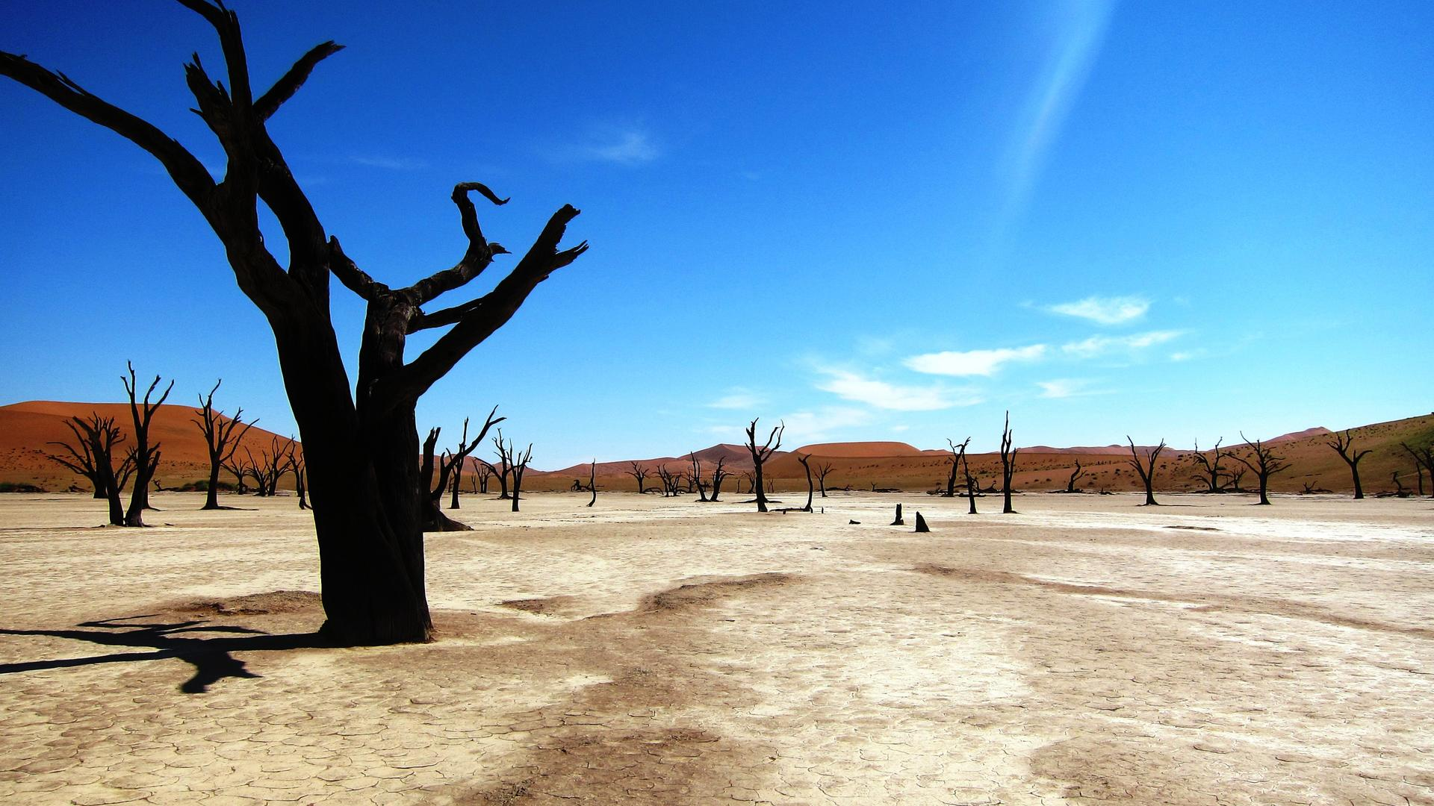
Day 4. September 17th, 2024: Living Desert Experience
Meals: Breakfast and dinner
After breakfast, we will depart for an amazing and unique tour of the desert!
Known as the Living Dunes Experience is an extraordinary exploration of the coastal dune belt just outside Swakopmund. To the untrained eye the dunes are just a pile of sand, however, the skilled and experienced guides will introduce visitors to a wealth of desert life. Often referred to a "Living Desert Tour", we will track Palmetto geckos, sand diving lizards, the famous fog-basking tok-tokkie beetle, sidewinder snakes, spiders, scorpions, and chameleons. As we explore this breath-taking terrain, we will share a lot of information on origin, weather and the special adaptations of its inhabitants.
Following our guided tour, we will go on a dune drive where we can have will have the opportunity to take some amazing photos!
We will then return to our lodge for some leisure time before getting ready for a sundowner cocktail and dinner.
For dinner this evening we will depart our lodge for a very special surprise dinner in a stunning location!
Overnight: Desert Breeze Lodge, Swakopmund
Day 5. September 18th, 2024: Transfer to Etosha and Game Drives
Meals: Breakfast, lunch, and dinner
Today, after breakfast you will be transferred to Swakopmund airport for your light aircraft flights(s) to Etosha National Park.
Once at Etosha National Park we will enjoy full and half day game drives in Namibia’s prime savannah wilderness area, allowing you to see the massive salt-pan and perennial springs that provide the water required by the Park’s high-density big game population.
Guided afternoon/evening game drives take place on the private Ongava Game Reserve. The reserve is famed for its population of rhino and lion, as well as other game such as the endemic black-faced impala.
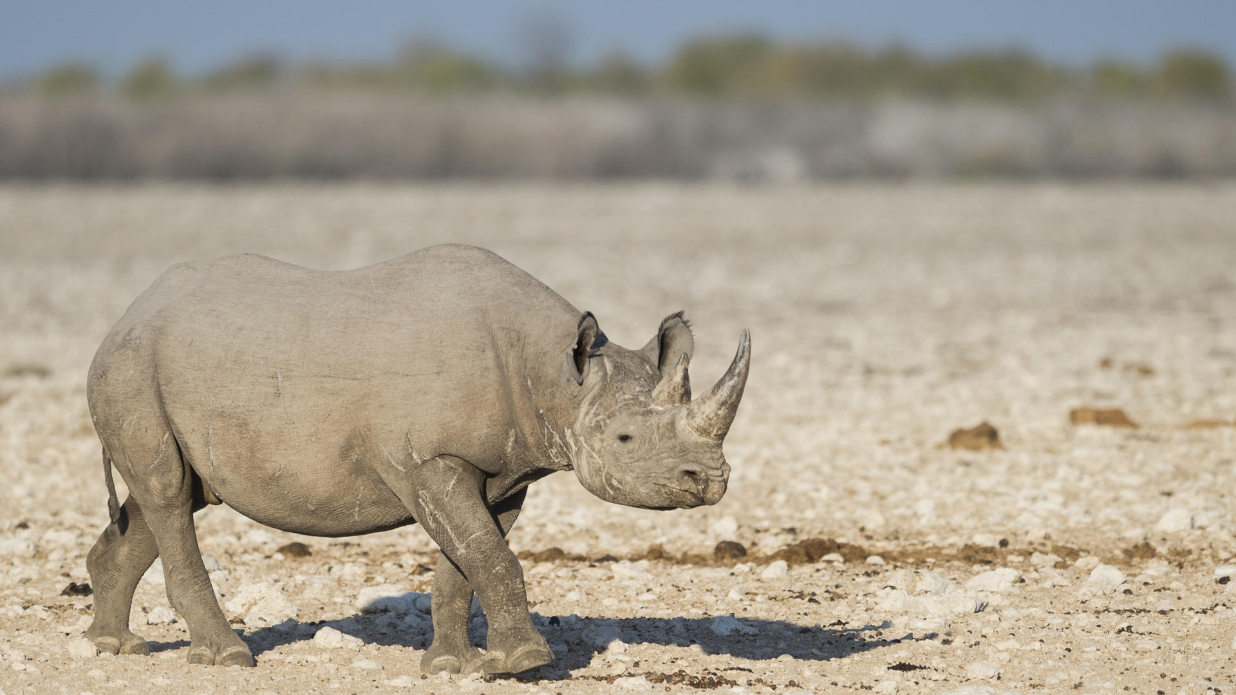
Optional Activities at Ongava
As well as our planned safari drives Ongava Game Reserve also offers some incredible optional activities!
Guided Nature Walks
Offered seasonally and subject to an available walking guide, the guided nature walks through the reserve will proudly showcase the abundant array of life, from the unusual plants to the arid-adapted animals with a chance of potentially approaching white rhino.
Game Hide
Andersson’s hide allows for unobtrusive game viewing of the camp’s waterhole. Often frequented by plains game including warthog, zebra, giraffe and an array of antelope, the waterhole also attracts larger game such as rhino and sometimes even lions.
Ongava Information System and Visitor Centre
Guests can interface with science and research across Anderssons and part of this experience is an immersion into the world of natural history and science at the new Ongava Visitor Centre. With dozens of in-depth displays that feature information on the geology, animals, plants and ecological functioning of this fascinating region, guests are encouraged to meander through the self-guided exhibition area.
Overnight: Anderssons At Ongava, Ongava Private Game Reserve
Day 6. September 19th, 2024: Full Day Game Drives and Optional Activities
Meals: Breakfast, lunch, and dinner
This morning, we will enjoy breakfast together before setting out on our full day safari!
We will enjoy full and half day game drives in Namibia’s prime savannah wilderness area, allowing you to see the massive salt-pan and perennial springs that provide the water required by the Park’s high-density big game population.
Guided afternoon/evening game drives take place on the private Ongava Game Reserve. The reserve is famed for its population of rhino and lion, as well as other game such as the endemic black-faced impala.
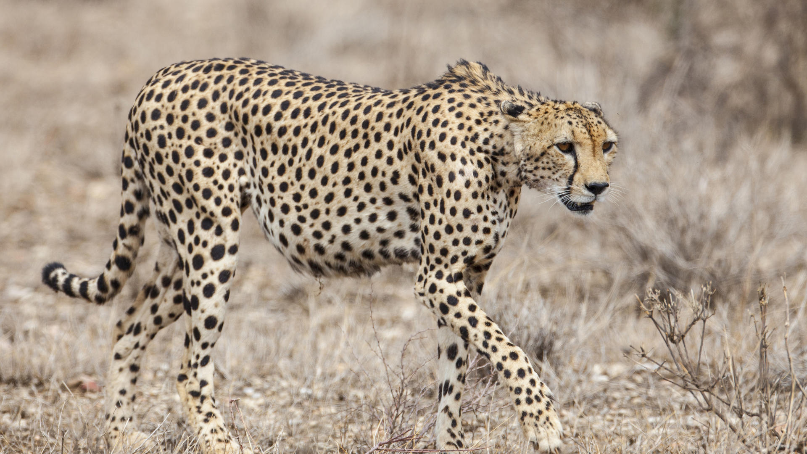
Optional Activities at Ongava
As well as our planned safari drives Ongava Game Reserve also offers some incredible optional activities!
Guided Nature Walks
Offered seasonally and subject to an available walking guide, the guided nature walks through the reserve will proudly showcase the abundant array of life, from the unusual plants to the arid-adapted animals with a chance of potentially approaching white rhino.
Game Hide
Andersson’s hide allows for unobtrusive game viewing of the camp’s waterhole. Often frequented by plains game including warthog, zebra, giraffe and an array of antelope, the waterhole also attracts larger game such as rhino and sometimes even lions.
Ongava Information System and Visitor Centre
Guests can interface with science and research across Anderssons and part of this experience is an immersion into the world of natural history and science at the new Ongava Visitor Centre. With dozens of in-depth displays that feature information on the geology, animals, plants and ecological functioning of this fascinating region, guests are encouraged to meander through the self-guided exhibition area.
Overnight: Anderssons At Ongava, Ongava Private Game Reserve
Day 7. September 20th, 2024: Full Day Game Drives and Optional Activities
Meals: Breakfast, lunch, and dinner
This morning, we will enjoy breakfast together before setting out on our full day safari!
We will enjoy full and half day game drives in Namibia’s prime savannah wilderness area, allowing you to see the massive salt-pan and perennial springs that provide the water required by the Park’s high-density big game population.
Guided afternoon/evening game drives take place on the private Ongava Game Reserve. The reserve is famed for its population of rhino and lion, as well as other game such as the endemic black-faced impala.
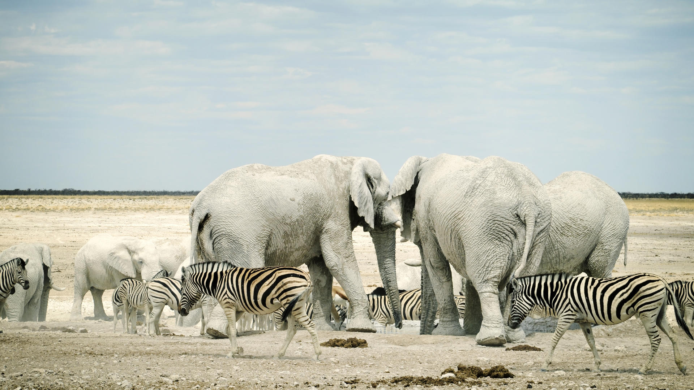

Optional Activities at Ongava
As well as our planned safari drives Ongava Game Reserve also offers some incredible optional activities!
Guided Nature Walks
Offered seasonally and subject to an available walking guide, the guided nature walks through the reserve will proudly showcase the abundant array of life, from the unusual plants to the arid-adapted animals with a chance of potentially approaching white rhino.
Game Hide
Andersson’s hide allows for unobtrusive game viewing of the camp’s waterhole. Often frequented by plains game including warthog, zebra, giraffe and an array of antelope, the waterhole also attracts larger game such as rhino and sometimes even lions.
Ongava Information System and Visitor Centre
Guests can interface with science and research across Anderssons and part of this experience is an immersion into the world of natural history and science at the new Ongava Visitor Centre. With dozens of in-depth displays that feature information on the geology, animals, plants and ecological functioning of this fascinating region, guests are encouraged to meander through the self-guided exhibition area.
Day 8. September 21st, 2024: Depart Namibia
Meals: Breakfast
After breakfast, we will check out of our accommodations and be transferred to the airstrip in time for your flight to Windhoek and onward connection to the United States
Alternatively, if you are joining us for the post trip extension on the Skeleton Coast, we will have a safety briefing before departing for the rugged skeleton coast!
Thank you for traveling with Limitless Planet!
Total Trip Cost: $6578
*Price based on double occupancy.
Please note this trip can only operate if six people are confirmed. If this minimum is not met, you will be fully refunded.
Included:
Accommodations:
1 night at Derwent House Boutique Hotel, Cape Town
3-nights Desert Breeze Lodge in the villa and bungalows on a bed and breakfast basis
3-nights Anderssons at Ongava on a fully inclusive basis
Light aircraft:
Swakopmund to Etosha
Etosha to Windhoek
*Please note there is a strict 44 pound soft sided luggage restriction.
Road transfers:
Round trip airport transfers from Cape Town airport to the hotel
Transfer from Walvis Bay Airport to the hotel
Open vehicle transfers from the bush airstrip to/from the lodge
Sightseeing:
Full day Flyaway Excursion to Sossusvlei including lunch (beverages excluded)
Private half day Living Desert Tour
Surprise dinner experience
Twice daily safari activities
Not Included:
- Any flight not specified
- Any meals not specified above
- Alcoholic beverages at meals
- Tips for guides, servers, and drivers
- Travel Insurance *This is strongly recommended for all travelers
- Visas *You will be issued a free visa upon your arrival in South Africa
- Personal Expenses: Laundry, phone calls, etc.
Lodging Highlights
Below is are some highlights of our incredible accommodations on this trip!
Cape Town, South Africa: Derwent House Boutique Hotel, Cape Town
This charming boutique hotel is Housed in a quaint, converted Victorian era residence in the heart of the vibrant Tamboerskloof/Gardens neighborhood, this small hotel combines historic charm, contemporary style and all mod-cons for a uniquely Capetonian blend of ambience, warmth and comfort.
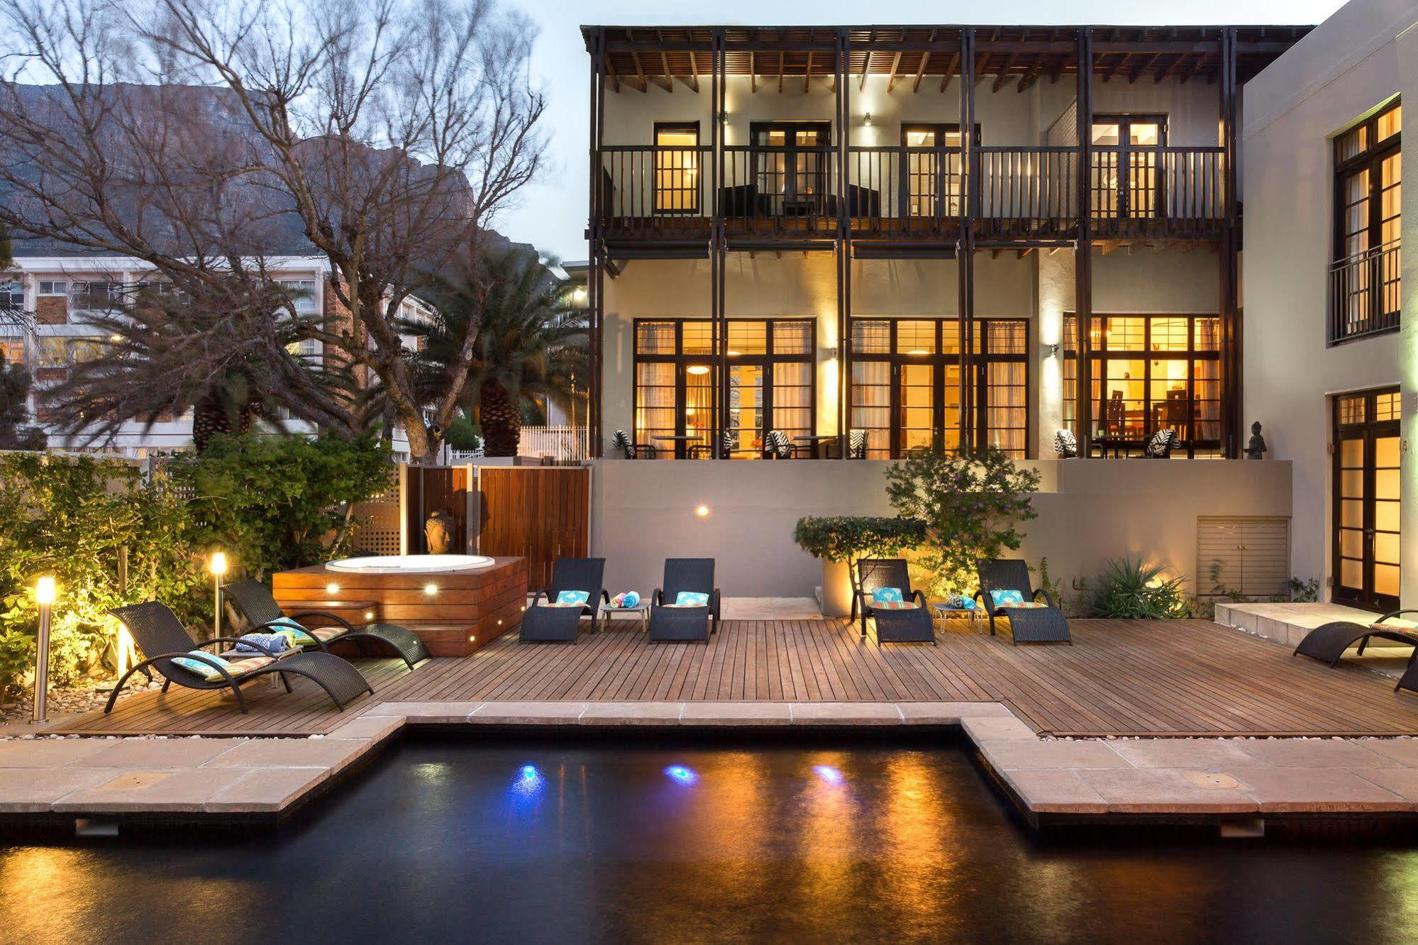
Swakopmund, Namibia: Desert Breeze Lodge
Staying at Desert Breeze it will feel like you are part or the Namib desert. You will be living “in the view” of the oldest desert in the world. Total peace and silence so close to Swakopmund. Surrounded by colorful and very unique architecture contrasting but yet fitting in with the desert landscape will sooth any soul. Big basalt sculptures stand guard over the desert landscape. The luxury bungalows with the creative feeling and friendly staff will make your stay very special. Desert Breeze offers 12, all en-suite, luxury bungalows and one exquisite villa, each with a private sun deck to admire the breath-taking view of the dunes. Expressing sophisticated style and luxury from our accommodation right through to our breakfast facilities, we endeavor to make our guests feel pampered and spoiled. Each bungalow and the villa are equipped with wireless internet, mini bar, coffee and tea making facilities and digital safes. The breakfast facility serves only the freshest of produce for breakfast. Seating is available indoors or on the deck for guest to enjoy the view and peaceful atmosphere. Secure parking as well as laundry facilities are available.
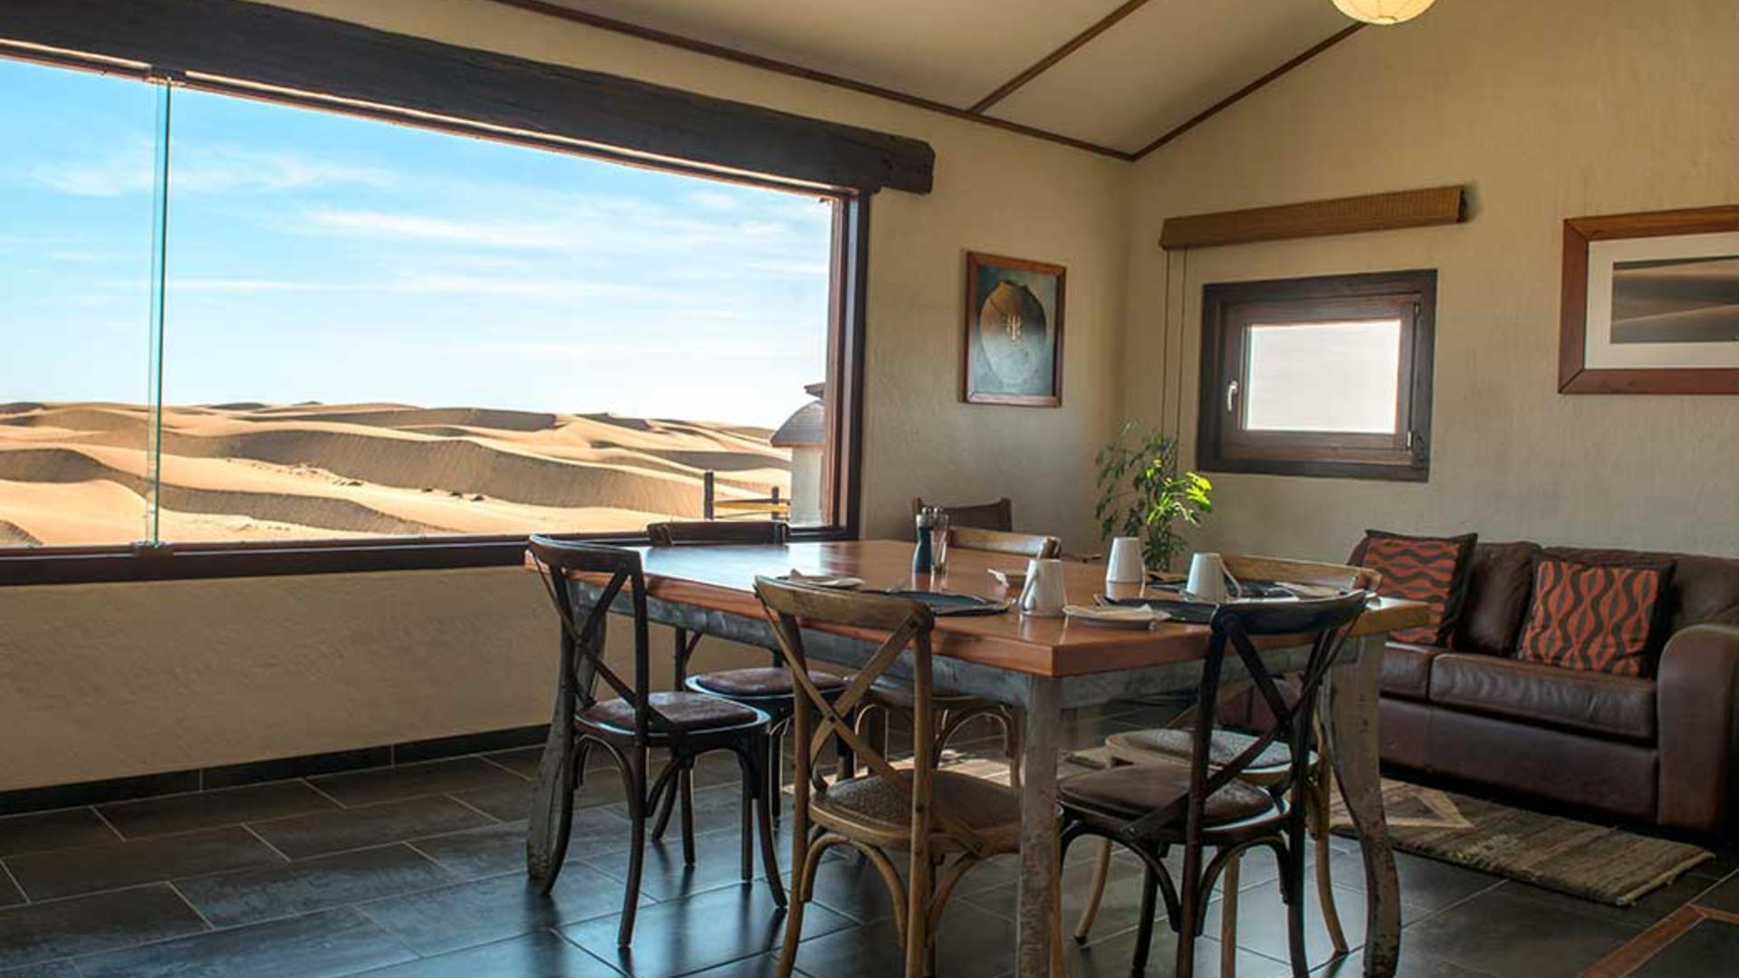

Ongava Private Game Reserve, Namibia: Andersons at Ongava
Nestled in mopane scrub on white calcrete soils, Andersson’s Camp is situated 4.5 km from Etosha’s Andersson Gate. The camp was named after Swedish explorer Charles Andersson – one of the first Europeans to “discover” Etosha, Africa’s largest saltpan. The resurrected former farmstead that stands on the site now forms the center of a charming camp fronting onto a productive waterhole. The 18 tented en-suite units (including two family suites) are raised on decks. The camp is an exciting example of sustainable construction; this model of eco-sensitive lodging provides an authentic, safe and down-to-earth experience for small groups, families and independent travelers to the Etosha region and is easily accessible by either road or air. Activities include morning and/or afternoon game drives in Etosha National Park, and morning and afternoon/evening drives (on request) and nature walks on Ongava Reserve. The sunken hide at the waterhole in front of camp is an excellent place from which to watch wildlife coming down to drink.

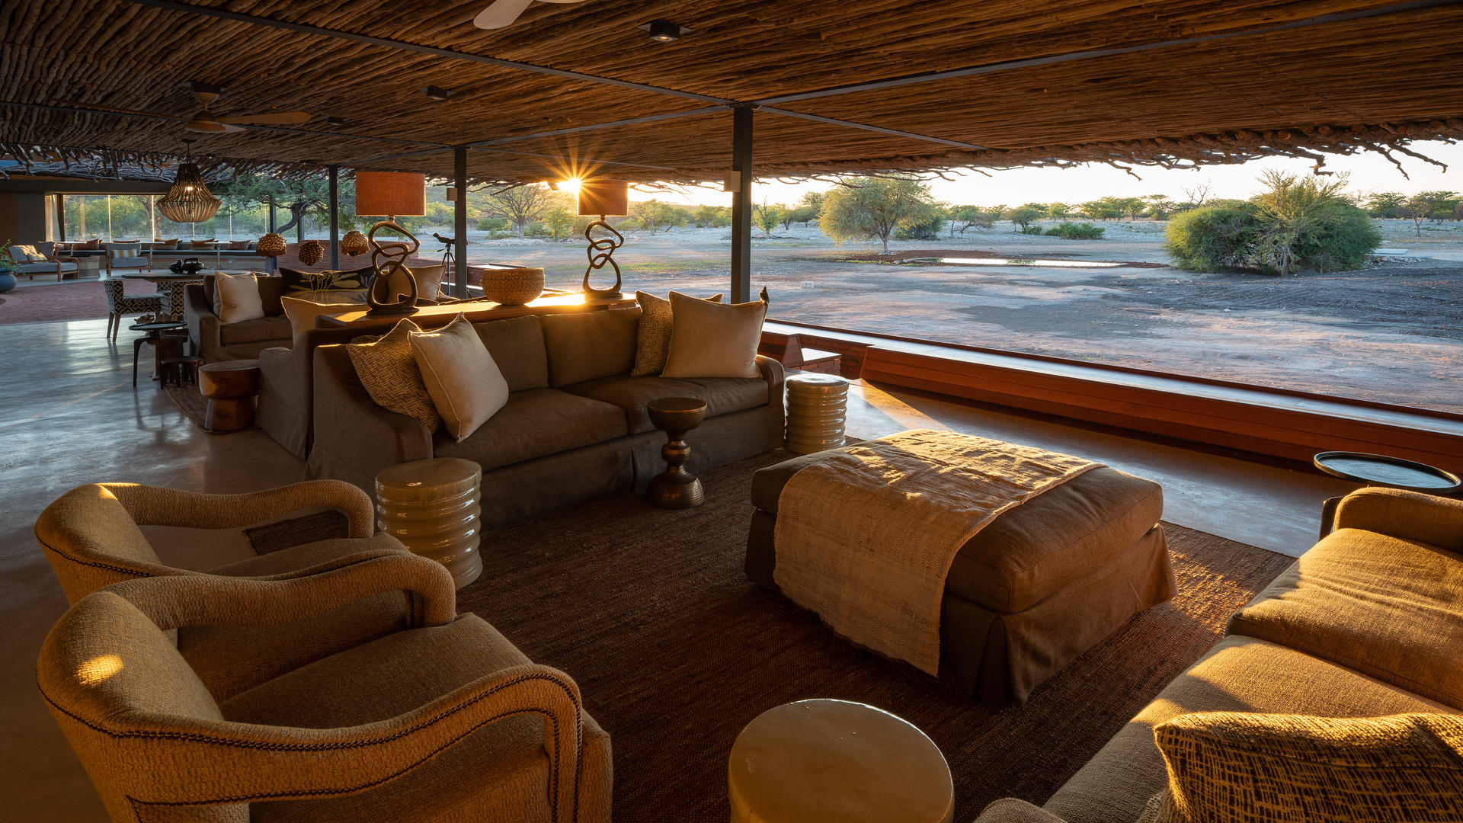

GENERAL INFORMATION:
Flights
If you would like Limitless Planet to make your flight arrangements, please reach out to your Account Manager. If you would like to use points or miles to book your flight, you will be in charge of booking your own flight.

Passport
Each traveler will be required to have a passport valid for at least six months after your travel departure date. Limitless Planet is happy to assist you with your passport application or renewing an expired passport. Additional fees may apply. Please send a copy of your valid passport with your deposit payment.

Visa
A free tourist visa will be issued to you upon your arrival in South Africa if you are over the age of 18. If you are a minor traveling with your parent or guardian, then you are exempt from this Visa issuing.

Travel Insurance
Travel insurance is not included in the quote of this itinerary. For your convenience Limitless Planet offers travel protection plans through Travelex Insurance Services. We are happy to send you a quote. A Limitless Planet Travel staff member will be onsite to assist in case of any emergency.

Concierge Service
Limitless Planet is happy to provide on-site VIP Concierge Service for the duration of your trip. Our on-site guides will ensure your restaurant reservations are made and your flights are on time. Our guides are experienced in managing the most intricate on-site details of today’s complicated programs. Be rest assured, you will have on-site assistance for any issue that occurs during your travels.

Health & Wellness
Your health and wellness are very important to us. We are happy to accommodate any dietary restriction and special requests. All participants of Limitless Planet’s tours must be physically fit enough to participate on the tour. Limitless Planet reserves the right to deny participation on any of our tours, according to the tour itinerary.

All guests are REQUIRED to have a COVID vaccination to travel with Limitless Planet.
IMPORTANT:
For every booking entrusted to us, we require the following information:
- Full passengers ́ name, date of birth, nationality & passport number
- International arrival/departure flight (if not arranging through Limitless Planet)
- Active medical problems
- Bed preference (subject to availability)

LIMITS ON LIMITLESS PLANET’S RESPONSIBILITY:
Limitless Planet acts as Tour Operator. It purchases transportation, hotel accommodations, restaurants and other services from various independent suppliers that are not subject to its control. Limitless Planet cannot, therefore, be liable for death, personal injury or any other loss that may occur due to any act or omission of any such a supplier or by reason of any other event over which it has no control. Domestic flights are, occasionally, subject to overbooking, cancellation, and schedule changes. If this occurs, Limitless Planet will do all in their power to assist clients in boarding flights or finding alternate arrangements. It must be stressed that this is done as a courtesy to clients and Limitless Planet cannot be held responsible for denied boarding, nor for the additional costs thus incurred; nor for payments not recovered for missed land arrangements due to airline delays.

Optional Activities that may be Dangerous
Depending on the itinerary you have selected, optional activities will be available at some of the places they will visit. Some of these activities carry with them the inherent risk of serious personal injury. These activities include, but are not limited to horseback tours, canoe trips, hiking, river rafting, etc. You should be aware that your personal safety cannot be guaranteed, and Limitless Planet assumes no responsibility for your safety.

Acts of God and the Like
Limitless Planet is not responsible for acts of God, fire, acts of local government or other authorities, wars, civil disturbances, riots, terrorist acts, strikes, thefts, pilferage, epidemics, quarantines, earthquakes, adverse weather conditions, dangers incident to sea, land, and air travel and other similar acts or incidents beyond its ability to control or its suppliers.

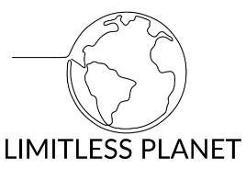
© COPYRIGHT LIMITLESS PLANET, LLC

